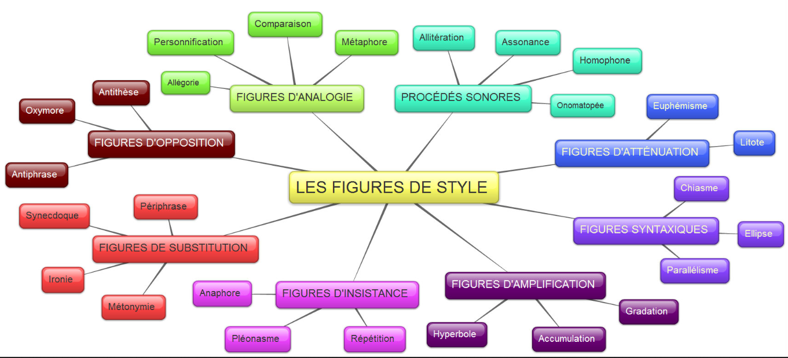
Cf. https://juliecote2004.files.wordpress.com/2012/03/carte-conceptuelle-sur-les-catc3a9gories-de-figures-de-style.jpg

Figures d’analogie

Figures d‘opposition
Procédés sonores

Figures d’insistance
Figures syntaxiques
Figures d’atténuation
Figures de substitution
Figures d’amplification
Figures
de style

